Erosion and Climate Change Challenges: Anambra State, Nigeria Case Study

Abstract
The study area; Anambra State is located in the south-eastern part of Nigeria. Soil erosion due to climate-induced flooding constitutes the major ecological challenge of the state.
The topography of the area in addition to the soil type and the incidence of flooding, consequence of heavy rainfall and surface water runoffs occasioned by climate change according to the Intergovernmental Panel on Climate Change (IPCC) fourth assessment report, necessitate the soil transport and severe gully erosion menace of this area. The state constitutes about 65% of gully erosion incidence in Nigeria.
Anthropological factors also accelerate the development and expansion of these gullies, with the attendant human vulnerability. Over 40% of the total land area in the state is currently severely eroded.
This paper classified the gully erosion in the area according to their severity and socioeconomic impact; it further analyses their consequence in the face of climate change challenges.

Keywords— gully erosion, human vulnerability, climate change.

Summary statement:
Soil erosion in the study area arising from increases in precipitation levels and heavy runoffs due to climatic variability has led to ecological disasters with its attendant human vulnerability

1.0 INTRODUCTION
Soil erosion is an ecological process in which soil is displaced faster than it can be replenished. In Anambra State and the south eastern zone of Nigeria, the agents of this soil displacement is basically flooding execrated by climatic variability. However human activities also accelerate the process of erosion in this area.
Basically, three (3) types of erosion occurs; sheet, rill and gully erosion. Gully erosion is the most prominent in this region. The topography and the soil characteristics enhance the accelerated spread of gullies in this area. The incidence of gully expansion is heightened during the rainy season, with the resultant effect of loss of agricultural land, residential areas and even human lives.

1.1 The Study Area
With a population of 4,182,032 million people, spread in a land mass of 44,116sq km; Anambra State in the Federal Republic of Nigeria is the most densely populated state in the southeastern part of the country. The state lies between latitude 5˚ 42´ N and 6˚ 47΄N and longitude 6˚ 37´ E and 7˚ 23´ E, being made up of 127 communities divided into 22 Local Government Areas.

The study area lies within the tropical region. The area is influenced by two climatic seasons, the dry and wet seasons. The wet season starts early late January/February, and comes in full by March and ends in Novermber, with a break in August. The average annual rainfall is about 1800mm concentrating between the months of May – November. The dry months lasts for four-five months.

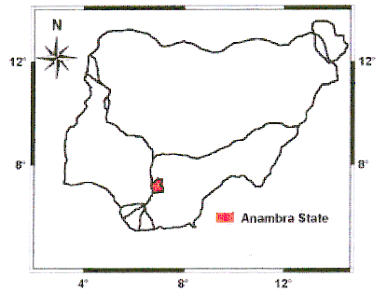
Figure 1: Map of Nigeria Showing the Study Area; Anambra State.

The prevailing winds are the southwesterlies which bring rains during the wet months and the notheasterlies or nothwerterlies which occur during the dry months and are known for the hazy harmattan conditions. The wind speeds are low, less than 2ms (4 knots) throughout the year.
The relative humidity is high all the year round; 80% at night and between 65%-75% during the day. The ambient air temperature varies between 25⁰C and 32⁰C. The mean daily temperature is 28⁰C, while the average annual temperature is 27⁰C. However the temperature can go up to 32⁰C during the hot periods of the year.
The main drainage system for the state is the Anambra River which empties into River Niger. The natural flow patterns of the river and streams in the area form a kind of drainage pattern in the area. The area is well drained. In general, two types of structures can be identified in the state; namely the uplifts and the basins of sedimentation.
The soil type is deep red, porous and unconsolidated. The land surface is covered with vegetation. The area use to be rainforest part of Nigeria that has been deforested due to civilization and urbanization. There are various economic trees found within the area.
Farming (subsistence agriculture), trading and small scale industries are the main source of economy of the state.

  - The Issue of Gully Erosion Problem in Anambra State.
The issue of gully erosion is a common phenomenon in the southeastern part of the country. Anambra State has the highest concentration of gully sites in this zone and the country at large. Every community in the state has their own story of woes to tell of the ever expanding gully erosion and the attendant consequences.

1.2.1 Gully Erosion Trigger Factors.
The causative agents of gully erosion in Anambra State are both geologic and anthropogenic. Natural erosion occurs primarily due to geologic timescale (Erosion Process, 2008). Anthropogenic forces (human activities) include; deforestation, unsustainable farming practice, laterite mining, poorly constructed drainage system, path and road construction. Soil erodibility depends to a extent on; soil texture, soil structure, soil permeability and amount of organic matter. The factors geologic and anthropogenic necessitating erosion are discussed below;

Soil Type
The soil type of the study area is porous, with the soil particles being loose not compacted, thus making them easily detachable. The nature of the soil accelerates the process of erosion when exposed to external forces such as flooding and human disturbances.

Topography
The topographic features of the area distinctly influence erosion potential. The region has most areas with pronounced rolling highly terrain. These areas have long steep slopes that enhance runoff velocity which gather momentum to produce force that speedily detach and transport soil particles, which results in gullies. This (once) lush, green land is now turning into an arid badland that’s [unsuitable] for cultivation, dangerous for human habitation and well on the way of becoming a parcel of useless land.

Agricultural Practices
The farming methodology practiced in the area is unsustainable. During farming large portion of the land is cleared or burnt exposing the fragile topsoil to erosion. Removal of groundcover increases the susceptibility of the soil to erosion. Disturbed land may have an erosion rate 1,000 times greater than normal (Erosion Process, 2008).

Settlement Pattern, Urban and Infrastructural Development
The area is densely populated, with a lot of developmental activities, a critical factor in erosion potential. Population density, an expression of number of persons per square kilometer of land is high for the state, about 798 persons/km² (NPC, 2007). Anambra State has properly the highest population density in the whole of sub-Saharan Africa (Igbokwe, 2007). It therefore follows that the issue of erosion problem shall put pressure on the human development potential of the state; such as water supply, housing, education, waste management etc.

LateriteMining
In this area laterite mining is a booming business due to the level of infrastructural development that requires the use of laterite. The issue of concern here is that the excavation is carried out for commercial purposes indiscriminately without any regards to the environmental consequences. The government of the day seems not to have done enough to check the ugly situation, thereby giving the culprits a field day.
1.2.2 Landuse & Landcover Mapping Scenarios of the State.
The landuse and landcover imagery data of the state available is as captured with Landsat EMT+ (2001) and NigeriaSat-1 (2005), and shown in the Fig 2 below.
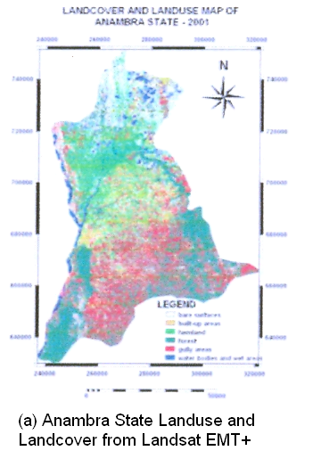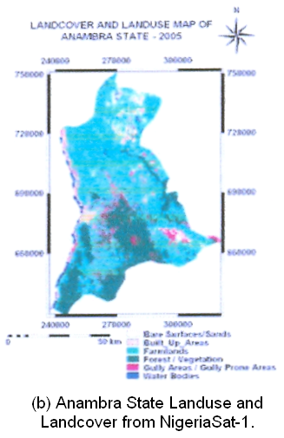

Fig 2: Landuse and Landcover Maps of Anambra State- (Landsat EMT+ & NigeriaSat-1)

The data obtained showed some variance but for built-up areas, forest/vegetation and water bodies. Table 1 gave the details of the results obtained.
S/N | Landuse & Landcover Type | Area (Km²)
 |  | Landsat ETM+ | NigeriaSat-1
1. | Bare and Exposed Surfaces | 822.94 | 168.47
2. | Built-up Areas | 243.74 | 316.79
3. | Farmlands | 782.72 | 2305.58
4. | Forest/Vegetation | 1814.06 | 1347.80
5. | Gully Areas | 906.16 | 498.72
6. | Water Bodies/Wet Areas | 166.16 | 107.94

Table 1: Result of Landuse and Landcover of Anambra State as depicted by Landsat EMT+ and NigeriaSat-1.
- GULLY EROSION SURVEY.
The imagery classification of gully erosion in the state combining the results obtained from Landsat EMT+ and NigeriaSat-1 shows that 1769.52 km² of the total land area of the state is severely gullied. The map of the classification is as shown in Fig 3 below.
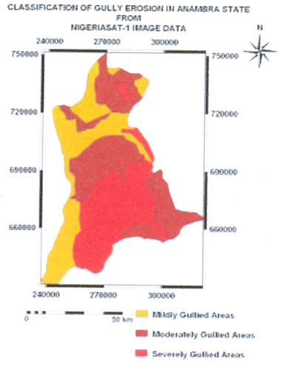

Fig 3: Image Classification of Gully erosion severity in Anambra State.

There are over 750 gully erosion sites in Anambra State. The state accounts for 65% of all gully erosion incidence of the whole nation. Available data showed that 1769.52 km² of the land area of the state or 40.1% are severely gullied, 1316.58 km² or 27.8% are moderately gullied and 1416.12 km² or 32.1% are mildly gullied. Fig 4 shows the picture of some of the gully sites in the state.

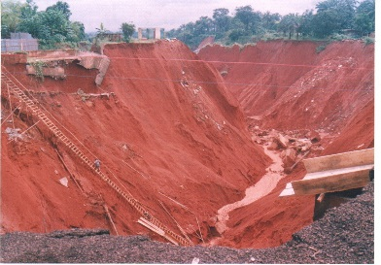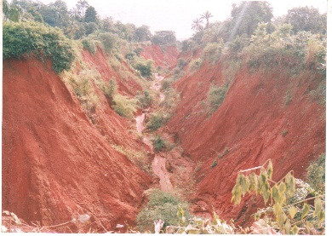

(a) A section of Agulu gully site (b) Umuchiana-Ekwuluobia gully site.

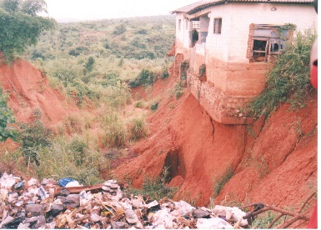

(c) Gully site at Onitsha, Anambra State.

Fig 4: Some of the gully erosion sites in the state.
- HUMAN VULNERABILITY OF GULLY EROSION IN ANAMBRA STATE.
Anambra State has 65% of the total gully erosion incidence in Nigeria. The consequences of gully erosion in Anambra State are so enormous that it is better imagined; every community in the state has their own story of woes to tell. The major issue of concern includes;
- Displacement of communities
- Loss of lives
- Loss of farmland
- Destruction of Houses
- Destruction of Highways, link roads and infrastructural development

4.0 CONCLUSION.
Our survey showed that the people are using local wisdom to combat gully erosion havoc they have to face and live with. They use sandbags, erect barriers, dig sallow containment wells, divert floods and dump refuse into the gullies as shown in pix – fig 4c; but all these efforts seems not enough to check the gully erosion havoc in the state.

We therefore recommend that a scientific and well articulated measure; “sensitivity index mapping” be put in place to proffer solution to the problem. These measures shall not only serve as an early warning signal but check the menace.

We also call for capacity building through the establishment of a “Geoinformatics Station” that will provide data on the area that area gullied or prone to gully erosion. A special fund shall be marked out to assist the state and the citizenry as gully erosion control is an expensive venture. The local people that are victims of this problem shall be properly educated on their practices & lifestyle that enhance gully erosion havoc and shall be equipped with methodologies of handling.

We also recommend advocacy on the mitigation and amelioration of the effects of gully erosion in Anambra State in particular, other southeastern states (that face similar gully erosion problem) and Nigeria in general.

Reference:
Dale S. (2000) “Preventing Gully Erosion in Nigeria” International Development Research Centre Publication. News 123 of 432
Erosion Processes (2008) “Chapter 2”.
Igbokwe J.I (2007) Gully Erosion Mapping/Monitoring in parts of South-Eastern Nigeria. Proceedings of Awareness Workshop on Gully Erosion Studies, Nnamdi Azikiwe University, Awka.
NPC (2007). 2006 Population Census of the Federal Republic of Nigeria. National Population Commission, Abuja.
Odogwu E.O (2007). “Nigeria: Erosion Clams 50 in Obosi”. Daily Champion (Lagos).

